Nama : Vionika Emalia Ismayana

NIM : 1918042

Kelas : D

1. Klasifikasi penyakit daun kentang

|  |  |  |  |  |  |
| --- | --- | --- | --- | --- | --- |
| **No** | **Citra** | **Red** | **Green** | **Blue** | **Pengelompokkan** |
| 1 |  | 0.225212 | 0.292328 | 0.133847 | Penyakit awal |
| 2 |  | 0.27492 | 0.328164 | 0.209889 | Penyakit awal |
| 3 |  | 0.405752 | 0.456996 | 0.384423 | Penyakit awal |
| 4 |  | 0.233708 | 0.259677 | 0.125697 | Penyakit awal |
| 5 |  | 0.305114 | 0.391058 | 0.244976 | Penyakit awal |
| 6 |  | 0.321937 | 0.355301 | 0.1573 | Penyakit awal |
| 7 |  | 0.22585 | 0.533989 | 0.417612 | Daun Sehat |
| 8 |  | 0.276799 | 0.382934 | 0.118863 | Daun Sehat |
| 9 |  | 0.277183 | 0.338884 | 0.205879 | Daun Sehat |
| 10 |  | 0.305557 | 0.357517 | 0.24544 | Daun Sehat |
| 11 |  | 0.233532 | 0.313851 | 0.227276 | Daun Sehat |
| 12 |  | 0.153167 | 0.387906 | 0.364001 | Daun Sehat |
| 13 |  | 0.419167 | 0.408612 | 0.272761 | Daun Sehat |
| 14 |  | 0.313857 | 0.297071 | 0.279625 | Daun Membusuk |
| 15 |  | 0.300892 | 0.371945 | 0.146696 | Daun Membusuk |
| 16 |  | 0.218028 | 0.256949 | 0.168448 | Daun Membusuk |
| 17 |  | 0.385864 | 0.431249 | 0.27821 | Daun Membusuk |
| 18 |  | 0.127859 | 0.205327 | 0.095656 | Daun Membusuk |
| 19 |  | 0.220414 | 0.252431 | 0.158197 | Daun Membusuk |
| 20 |  | 0.165474 | 0.235265 | 0.0739917 | Daun Membusuk |

1. Desain GUI

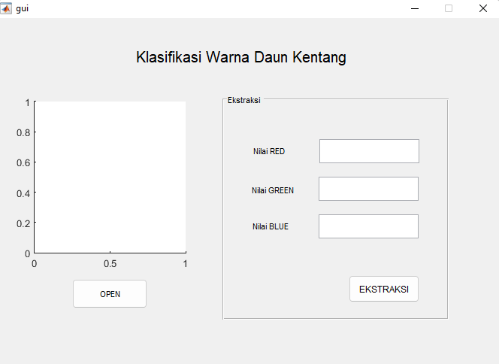

1. Penjelasan Source Code
2. Sourcecode button OPEN

|  |
| --- |
| % --- Executes on button press in pushbutton1.  function pushbutton1_Callback(hObject, eventdata, handles)  % hObject handle to pushbutton1 (see GCBO)  % eventdata reserved - to be defined in a future version of MATLAB  % handles structure with handles and user data (see GUIDATA)  [nama_file, nama_path] = uigetfile({'*.jpg;*.bmp;*.tif'}, 'membuka gambar'); %memilih gambar    % jika ada file yang dipilih maka akan mengeksekusi perintah di bawahnya  if ~isequal(nama_file,0)  % membaca file citra  Img = im2double(imread(fullfile(nama_path, nama_file)));  % menampilkan citra pada axes 1  axes(handles.axes1)  imshow(Img)  % menyimpan variabel Img pada lokasi handles  handles.Img = Img;  guidata(hObject, handles)  else  % jika tidak ada file yang dipilih maka akan kembali  return  end |

b. Sourcecode button EKSTRAKSI

|  |
| --- |
| % --- Executes on button press in pushbutton2.  function pushbutton2_Callback(hObject, eventdata, handles)  % hObject handle to pushbutton2 (see GCBO)  % eventdata reserved - to be defined in a future version of MATLAB  % handles structure with handles and user data (see GUIDATA)  Img = handles.Img;  % konversi citra RGB menjadi grayscale  Img_gray = rgb2gray(Img);  % konversi citra grayscale menjadi biner  bw = im2bw(Img);  % operasi morfologi  bw = imcomplement(bw);  bw = imfill(bw,'holes');  bw = bwareaopen(bw,100);  % ekstraksi komponen RGB  R = Img(:,:,1);  G = Img(:,:,2);  B = Img(:,:,3);  % mengubah nilai background menjadi nol  R(~bw) = 0;  G(~bw) = 0;  B(~bw) = 0;    Red = sum(sum(R))/sum(sum(bw));  Green = sum(sum(G))/sum(sum(bw));  Blue = sum(sum(B))/sum(sum(bw));    set(handles.edit1,'string',Red);  set(handles.edit2,'string',Green);  set(handles.edit3,'string',Blue); |